Example

https://www.tutorialspoint.com/compile_cpp_online.php
https://www.tutorialspoint.com/compile_c_online.php

The following is an example for binary tree.

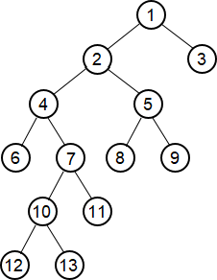

#include <iostream>
#include <queue>
#include <bits/stdc++.h>
#include <map>

using namespace std;

struct Node
{
int data;
Node *left = NULL;
Node *right = NULL;

Node(int i)
{
data = i;
}
};

void inorder(Node *node)
{
if (node == NULL)
{
return;
}

inorder(node->left);
printf("%d ", node->data);
inorder(node->right);
}

Node *CreateTree()
{
Node *root = new Node(1);
Node *n2 = new Node(2);
Node *n3 = new Node(3);
Node *n4 = new Node(4);
Node *n5 = new Node(5);
Node *n6 = new Node(6);
Node *n7 = new Node(7);
Node *n8 = new Node(8);
Node *n9 = new Node(9);
Node *n10 = new Node(10);
Node *n11 = new Node(11);
Node *n12 = new Node(12);
Node *n13 = new Node(13);

root->left = n2;
root->right = n3;
n2->left = n4;
n2->right = n5;
n4->left = n6;
n4->right = n7;
n5->left = n8;
n5->right = n9;
n7->left = n10;
n7->right = n11;
n10->left = n12;
n10->right = n13;

return root;
}

int main()
{
Node *root = CreateTree();

inorder(root);
}

This is another example for binary tree.

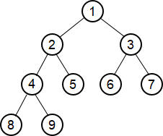

Node *CreateTree()
{
Node *root = new Node(1);
Node *n2 = new Node(2);
Node *n3 = new Node(3);
Node *n4 = new Node(4);
Node *n5 = new Node(5);
Node *n6 = new Node(6);
Node *n7 = new Node(7);
Node *n8 = new Node(8);
Node *n9 = new Node(9);

root->left = n2;
root->right = n3;
n2->left = n4;
n2->right = n5;
n3->left = n6;
n3->right = n7;
n4->left = n8;
n4->right = n9;

return root;
}

int main()
{
Node *root = CreateTree();
inorder(root);
}

This is another example for binary search tree.

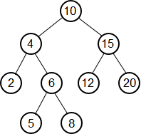

Node *CreateTree()
{
Node *root = new Node(10);
Node *n2 = new Node(4);
Node *n3 = new Node(15);
Node *n4 = new Node(2);
Node *n5 = new Node(6);
Node *n6 = new Node(12);
Node *n7 = new Node(20);
Node *n8 = new Node(5);
Node *n9 = new Node(8);

root->left = n2;
root->right = n3;
n2->left = n4;
n2->right = n5;
n3->left = n6;
n3->right = n7;
n5->left = n8;
n6->right = n9;

return root;
}

int main()
{
Node *root = CreateTree();
inorder(root);
}

- Create a linked list.

struct Node
{
int data;
Node *next;

Node(int d)
{
data = d;
next = NULL;
}
};

void printlist(Node *head)
{
while (head != NULL)
{
cout << head->data << " -> ";
head = head->next;
}
cout << "NULL";
}

// build a list: 1 -> 2 -> ... -> n
Node *buildList(int n)
{
int i = n;
Node *head = NULL;

while (i > 0)
{
Node *node = new Node(i);
node->next = head;
head = node;
--i;
}

return head;
}

// build a list: a[0] -> a[1] -> ... -> a[n-1]
Node *buildList(int a[], int n)
{
Node *head = NULL;
for (int i = n-1; i >= 0; --i)
{
Node *n = new Node(a[i]);
n->next = head;
head = n;
}
return head;
}

- Print a matrix or an array.

#define M 4
#define N 5

void printm(int mat[][N], int m, int n)
{
for (int i = 0; i < m; ++i)
{
for (int j = 0; j < m; ++j)
{
printf("%3d ", mat[i][j]);
}
printf("\n");
}
}

void printa(int a[], int n)
{
for (int i = 0; i < n; ++i)
{
printf("%d ", a[i]);
}
cout << endl;
}

- Factorial and combination

int factorial(int n)
{
if (n == 1) return 1;
return factorial(n-1) * n;
}

int combination(int n, int k)
{
if (n < k) return 0;
if (n == k) return 1;
return factorial(n) / factorial(k) / factorial(n-k);
}

int gcd(int m, int n)
{
if (n > 0) return gcd(n, m % n);
return m;
}

